Microsoft Teams meeting
Join on your computer or mobile app
Click here to join the meeting
Or call in (audio only)
+1 209-425-4338,,552704106# United States, Stockton
Phone Conference ID: 552 704 106#
Find a local number | Reset PIN
Learn More | Meeting options

MEETING MINUTES OF THE JUNE 23, 2021 MEETING

- Welcome / Facilitator Information: City of Newman
City of Newman opened meeting and welcomed everyone to the June 23, 2021 meeting.
- Introductions
Introductions were made.
- Approve minutes
A motion was made to approve the March 24, 2021 meeting minutes and seconded and approved by unanimous vote.
- SJVSWQP Regional Training Update- Post Training
Committee reported that 64 people attended the training and it went smoothly. The sessions are available for our use; email Kathy Grant if you would like a copy. The balance of our fund is $3206.88. Next meeting we will discuss and pay Compliance First.
- CVRWQCB June 7, 2021 Letter Re: LOWER SAN JOAQUIN RIVER, SAN JOAQUIN RIVER, STOCKTON DEEP WATER SHIP CHANNEL ORGANIC ENRICHMENT AND LOW DISSOLVED OXYGEN TOTAL MAXIMUM DAILY LOAD
Karen gave a brief update. she will review in more detail and give us a report about what the letter means at the next meeting.
- NPDES Phase II Permit Update
We are still waiting for the draft permit. it may come out in the fall for our review. Possible new permit fall of 2022. CASQA committees are involved and preparing to comment when draft comes out. Our group agreed to review and comment when the draft comes out. Keep this on the agenda.

CASQA Updates
CASQA has several committees and meeting we can participate in. the next Quarterly meeting is July 15th. The virtual training is Oct 26-27, 2021. Visit CASQA Website.
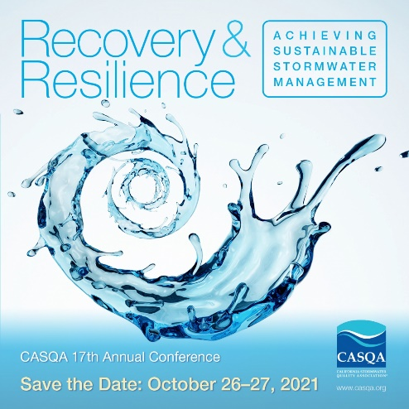
- Delta RMP Updates
Changes and updates are happening internally on the governmental structure of the group. Invoices went out.
- CV Salts Updates
Waiting for Stephanie to give us current info since she is most knowledgeable
- New Business
Add News letter sent by EPA to discuss new tool CLASSC
Add Pyrethroid plan and reminder that the plan is due August 19th, 2021.

- Next Meeting (Date: July 28,2021 Location: Virtual or in Person
  - Host City: ( Patterson )
Discussed whether to have in person meetings or not. Caleb is going to send out a survey to see how everyone feels about it. Patterson is hosing next and will attempt an in person and virtual combination.

